## A Walk through with General Adversarial Network(GAN) in the context of Modern Machine Learning Approaches

Somodyuti Pal

Artificial intelligence will shape our future more powerfully than any other innovation this century.in recent years there had been much improvement of the domain of A.I and its sub field Machine Learning.Rapid advances in data storage and computer processing power have dramatically changed the game in recent years.

With Neural Networks a mathematical model similar to human brain architecture,we have made great progress in Machine Learning. They now recognize images and voice at levels comparable to humans. They are also able to understand natural language with a good accuracy.But, even then, the talk of automating human tasks with machines looks a bit far fetched. After all, we do much more than just recognizing image / voice or understanding what people around us are saying.This leads to a creative need for Artificial intelligence and General Adversarial Network is a Modern Approach of Machine learning to satisfy it.

Another Approach of Deep Learning is very famous.The purpose of deep learning is to discover rich, hierarchical models , that represent probability distributions over the kinds of data encountered in artificial intelligence applications, such as natural images, audio wave forms containing speech, and symbols in natural language corpora. The striking successes of Deep learning have primarily been based on the back propagation and dropout algorithms, using piece wise linear units which have a particularly well-behaved gradient.

But again the need of Creativity is not fulfiled by deeplearning it can detecte or classify very well but it can not generate a source of data.So [GANs were introduced in a paper](https://arxiv.org/abs/1406.2661" \t "https://skymind.ai/wiki/_blank) by Ian Goodfellow and other researchers at the University of Montreal, including Yoshua Bengio, in 2014. Referring to GANs, Facebook’s AI research director Yann LeCun [called adversarial training](https://www.quora.com/What-are-some-recent-and-potentially-upcoming-breakthroughs-in-deep-learning" \t "https://skymind.ai/wiki/_blank) “the most interesting idea in the last 10 years in ML.”

* ***WHAT IS GAN:-***

In one line, we can say Generative adversarial networks (GANs) are deep neural net architectures comprised of two neural networks, competing one against the other (thus the “adversarial”).

They learn to copy the data distribution of the data you give it, and therefore can generate novel images that look alike.So GAN stands out as no other model had the concept of data generation and this data generation technique makes the patterns and structure of data's source clearly visible.

In this adversarial nets framework, the generative model is pitted against an adversary: a discriminative model that learns to determine whether a sample is from the model distribution or the data distribution. The generative model can be thought of as analogous to a team of counterfeiters,trying to produce fake currency and use it without detection, while the discriminative model is analogous to the police, trying to detect the counterfeit currency. Competition in this game drives both teams to improve their methods until the counterfeits are indistinguishable from the genuine articles.



Simple layout of GAN model

Then, the counterfeiter practices even more, and learns to make cash that’s just slightly more realistic, and ends up tricking the policeman/Discriminator (since he’s really lazy, and learned a really bad classifier).

The cycle repeats for some time, until the policeman/Discriminator cannot tell the difference between the fake cash and the real cash, since the fake cash looks exactly like the real cash. Once this is done, we can just use the generator to make fake cash forever.This data generation is very esential for unsupervised learning algorithms of Machine Learning.

* ***How GAN Thinks:-***

The Generator Network takes an random input and tries to generate a sample of data. In the above image, we can see that generator G(z) takes a input z from p(z), where z is a sample from probability distribution p(z). It then generates a data which is then fed into a discriminator network D(x). The task of Discriminator Network is to take input either from the real data or from the generator and try to predict whether the input is real or generated. It takes an input x from pdata(x) where pdata(x) is our real data distribution. D(x) then solves a binary classification problem using sigmoid function giving output in the range 0 to 1.

Let us define the notations we will be using to formalize our GAN,Pdata(x) -> the distribution of real data,X -> sample from pdata(x),P(z) -> distribution of generator,Z -> sample from p(z),G(z) -> Generator Network,D(x) -> Discriminator Network.

Now the training of GAN is done (as we saw above) as a fight between generator and discriminator. This can be represented mathematically as:-

In our function V(D, G) the first term is entropy that the data from real distribution (pdata(x)) passes through the discriminator (aka best case scenario). The discriminator tries to maximize this to 1. The second term is entropy that the data from random input (p(z)) passes through the generator, which then generates a fake sample which is then passed through the discriminator to identify the fakeness (aka worst case scenario). In this term, discriminator tries to maximize it to 0 (i.e. the log probability that the data from generated is fake is equal to 0). So overall, the discriminator is trying to maximize our function V.

On the other hand, the task of generator is exactly opposite, i.e. it tries to minimize the function V so that the differentiation between real and fake data is bare minimum. This, in other words is a cat and mouse game between generator and discriminator!

The image for generation and discrimination of an image:-



* ***Training of a GAN:-***

we want the generator to create images with D(x) = 1. So we can train the generator by backpropagation this target value all the way back to the generator, i.e. we train the generator to create images that towards what the discriminator thinks it is real.

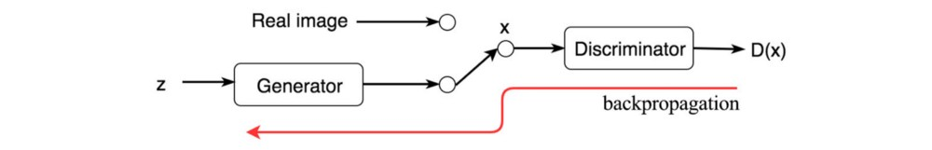

We train both networks in alternating steps and lock them into a fierce competition to improve themselves. Eventually, the discriminator identifies the tiny difference between the real and the generated, and the generator creates images that the discriminator cannot tell the difference. The GAN model eventually converges and produces natural look images.

This discriminator concept can be applied to many existing deep learning applications also. The discriminator in GAN acts as a critic. We can plug the discriminator into existing deep learning solutions to provide feedback to make it better.

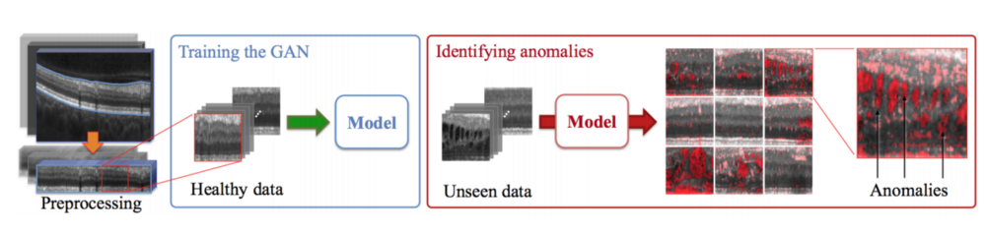

* ***Uses of GAN:-***

1. ****High-resolution image synthesis****
2. ****Text to image (Give a situation as text input get a output of picture)****
3. ****Face synthesis(Facial Emotion recognition)****
4. ****Video generation****
5. ****Music generation****
6. **Cross-domain transfer**

**And many more applications of GAN is upcoming day by day.**

* ***Conclusion:-***

However this training part of GAN has been a topic of interest among researchers and scientists,Generally it is hard to train a GAN network but it can give fascinating Results upon complitation.GAN gave us a new view over classical data science/ML approaches and it gives us a lead to the source of the data which is very essential for Unsupervised Machine Learning .

It has a wide range of scope of future scope in AI Models,and its overwhelming perfection can lead us to various opportunities.In 2017 GAN produced 1024 × 1024 images that can fool a talent scout. In coming years, we will probably see high-quality videos generated from GANs. The commercial applications will come by the time.